Surface Book
Fact Sheet
October 2015
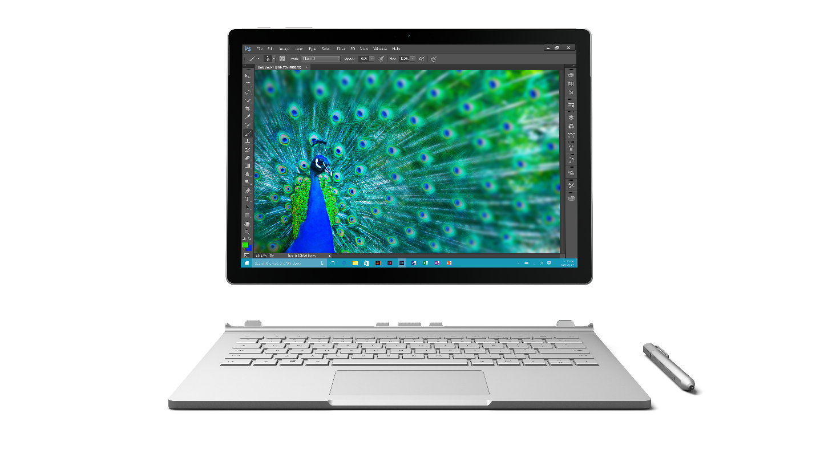
Meet Surface Book, Microsoft’s laptop redefined. Designed with the quality and workmanship that have characterized Surface from the beginning, Surface Book combines 6th Generation Intel® Core™ i5 and Core™ i7 processors and up to 1 TB of storage with Intel® HD graphics 520, optional discrete NVIDIA® GeForce® graphics, an integrated backlit keyboard, responsive glass trackpad, and detachable screen-turned-tablet featuring a 13.5-inch PixelSense™ Display. Starting at $1,499, Surface Book is a high-performance laptop with exceptional power and unprecedented versatility that flexes to meet the demands of your work — from the art studio to the board room.

Top Features and Benefits
- Creative powerhouse. Design, sketch and build without limits. Surface Book is designed to be your creative powerhouse, built for the most demanding creative tasks. Edit photos and videos in graphics-heavy programs with amazing fluidity and smoothness. With up to 12 hours of battery life for video playback to take you through your day, Surface Book is the ultimate laptop to power your ideas.
- Draw, write and create on the go. Quickly and easily detach the screen to use it like a clipboard, and take advantage of its advanced touch and precise inking experience, or rotate and reattach to continue using the hardware-accelerated graphics. Plus, the updated Surface pen offers the ultimate modern writing experience, now with 1,024 levels of pressure sensitivity and reduced latency. When attached to the base, Surface Book enables quiet typing and more words per minute with a keyboard built for comfort, accuracy and efficiency.
- Best-in-class screen. With 6 million pixels, 1800:1 contrast ratio and 100 percent sRGB color, Surface Book’s 13.5-inch PixelSense™ Display offers stunning clarity and incredible resolution. Surface Book is individually calibrated for true-to-life color, with extremely high contrast and low glare.
- Experience Windows 10. With full Windows 10 Pro, Surface Book is compatible with virtually all your favorite software, including apps, programs like Microsoft Office, and professional-grade software such as Citrix⁴ and Visual Studio⁴.

Technical Specifications
Operating System | Windows 10 Pro
Exterior | Dimensions:  Laptop: 9.14 x 12.3 x 0.51-0.90 inches (232.1 x 312.3 x 13.0-22.8 mm)  Tablet only: 8.67 x 12.3 x 0.30 inches (220.2 x 312.3 x 7.7 mm)  Weight:  Laptop: Non-GPU: 3.34 lbs. (1515 g), GPU: 3.48 lbs. (1579 g)  Tablet only: 1.6 lbs. (726 g)  Mechanical features: Magnesium body, Dynamic Fulcrum Hinge, One-button Muscle Wire detach mechanism  Color: Silver  Physical clipboard buttons: power, volume
Storage | Solid-state drive (SSD) PCIe 3.0: 128 GB, 256 GB, 512 GB or 1 TB1
Display | Screen: 13.5-inch PixelSense™ Display  Resolution: 3000x2000 (267 ppi)  Contrast ratio: 1800:1  Aspect ratio: 3:2  100 percent sRGB color, individually calibrated  Touch: 10-point multitouch
CPU | 6th Generation Intel® Core™ i5 or Core™ i7
Graphics | Intel® HD graphics 520 and optional NVIDIA® GeForce® Graphics Processor with dedicated 1GB GDDR5 high-speed memory
Memory | 8 GB or 16 GB RAM
Keyboard & Trackpad | Full-size, integrated backlit keyboard with 1.6mm key travel  Precision trackpad with glass laminated trackpad (7,350 sq. mm)  Five-finger contact recognition with full Windows 10 support  Subpixel resolution
Security | TPM 2.0 chip for enterprise security
Pen | Surface Pen  1,024 levels of pressure sensitivity  Magnetic storage
Network | 802.11ac 2x2 MIMO Wi-Fi wireless networking; IEEE 802.11a/b/g/n compatible  Bluetooth 4.0 LE wireless technology
Battery | Up to 12 hours battery life for video playback³
Cameras | Windows Hello⁵ face-authentication camera (front-facing)  8.0MP rear-facing auto-focus camera, with 1080p HD camera  5.0MP front-facing 1080p HD camera
Audio | Dual microphones, front- and rear-facing  Front-facing stereo speakers with Dolby® audio
Ports | Two full-size USB 3.0  Full-size SD™ card reader (UHS-II performance)  Surface Connect for power and docking (base and clipboard)  Stereo headphones/microphone jack  Mini DisplayPort
Sensors | Ambient light sensor  Accelerometer  Gyroscope  Magnetometer
Power supply | 36W power supply with USB charging port  65W power supply with USB charging port (discrete GPU SKU)
In the box | Surface Book  Surface Pen  Power supply  Quick Start Guide  Safety and warranty documents
Warranty | One-year limited hardware warranty⁶

Pricing
128 GB 6th Generation Intel® Core™ i5 with 8 GB of RAM | $1,499 ERP
256 GB 6th Generation Intel® Core™ i5 with 8 GB of RAM | $1,699 ERP
256 GB 6th Generation Intel® Core™ i5 with 8 GB of RAM and NVIDIA® GeForce® Graphics Processor | $1,899 ERP
256 GB 6th Generation Intel® Core™ i7 with 8 GB of RAM and NVIDIA® GeForce® Graphics Processor | $2,099 ERP
512 GB 6th Generation Intel® Core™ i7 with 16 GB of RAM and NVIDIA® GeForce® Graphics Processor | $2,699 ERP

¹ System software uses significant storage space. Available storage is subject to change based on system software updates and apps usage. See http://www.microsoft.com/surface/storage for more details.
² Estimated retail price. Actual retailer prices may vary.
³ Testing conducted by Microsoft in September 2015 using preproduction Intel Core i5, 256GB, 8GB RAM device. Testing consisted of full battery discharge during video playback. All settings were default except Wi-Fi was associated with a network and Auto-Brightness disabled. Battery life varies significantly with settings, usage and other factors.
⁴ Sold separately.
⁵ Windows Hello requires specialized biometric hardware.
⁶ In the U.S.; warranty terms vary by market.

Contact Information
For more information, press only:
Rapid Response Team, WE Communications, (503) 443-7070, rrt@we-worldwide.com

For more product information and images:
Visit the Surface Newsroom at http://www.microsoft.com/en-us/news/presskits/surface.

For more information about Surface:
Visit Surface at http://www.microsoft.com/surface.

